**LOW LEVEL DESIGN DOCUMENT**

**FOOD DELIVERY**

**APPLICATION**

Class Diagram

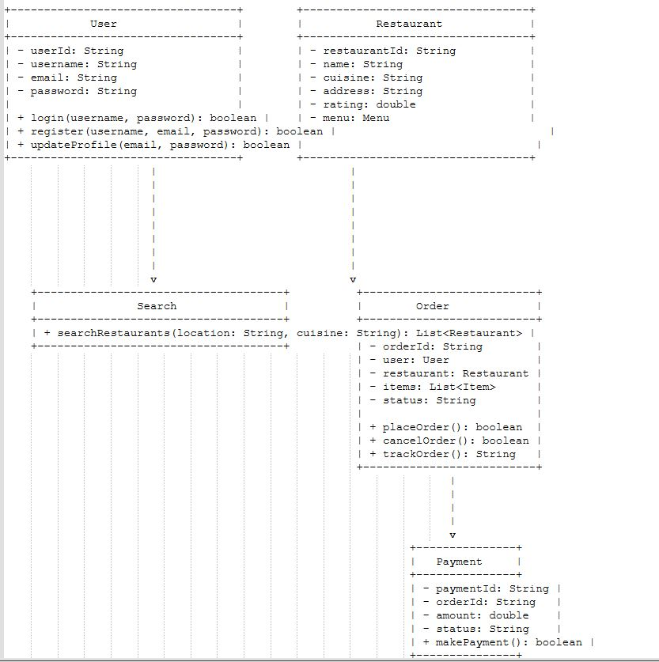

Sequence diagram

